First Iteration First Report:

mycheapfriend.com

# COMS 4156: Advanced Software Engineering

# Team: CheapSkates

## Team Members

## Double Trouble: Waseem Ilahi (wki2001@columbia.edu)

## Shaoqing Niu ([sn2385@columbia.edu](mailto:sn2385@columbia.edu))

## Dynamic Duo: Michael Glass (mgg2102@columbia.edu)

## Huning "David" Dai (hd2210@columbia.edu)

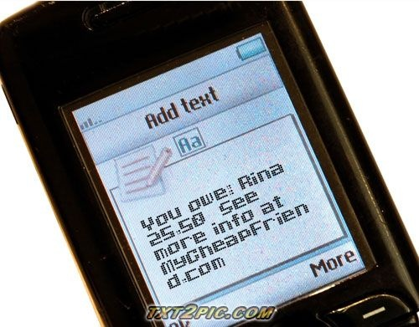

The **Cheapskates** from **MyCheapFriend.com** will lend you our **First Progress Report,** if you give us back feedback next week.

# 2. Revised Requirements: (Updated Priorities)

## Functional Requirements

1.    Accounts (High)

.       Administrative as well as regular users.

2.      Messaging (High)

.       E-mail and text message based UI.

## Non-Functional Requirements

1.      Security (High)

.       Very simple. Address Parsed from the text or email.

2.      Compatibility (medium)

.       Messages must be readable with multiple options (txt/html).

3.      Usability (Medium)

.       Easy to read.

## Use Cases

The Almanac is a system for settling small debts amongst friends. The following use cases will describe the complete functionality of the system as well as rank different features in terms of their importance.

### Account Management

#### Creating an account (high)

In order to bill friends, you need to create an account.  Creating an account involves texting new_account@mycheapfriend.com.  new_account@mycheapfriend.com responds with a unique e-mail address to text to and use as a security token.  The text looks like this, "your unique address is <gop1bi@mycheapfriend.com> Please add it to your address book (as CheapFriend?)".  This authenticates users against their unique e-mail address and treats their phone number as a unique user-id.

#### Changing a Password (medium)

If your password has been compromised or you want to change your security token for any other reason, you can text reset_pass@mycheapfriend.com from the cell phone that is associated with the account.  The old security token will be marked, "disabled" internally and any e-mails to its address will respond with an error telling the user to update their security token or e-mail [reset_pass@mycheapfriend.com](mailto:reset_pass@mycheapfriend.com).

#### 1.3)  Unsubscribing from MyCheapFriend.com (medium)

If you are either a user who wants to disable your account, or a bill-ee who does not want to receive any notifications from mycheapfriend.com, any text to unsubscribe@mycheapfriend.com will add the reply-to address to a block list and will not contact them again.

#### 1.4)  Re-subscribing from MyCheapFriend.com (medium)

If you would like to re-enable access to MyCheapFriend.com after unsubscribing, a text to resubscribe@mycheapfriend.com will remove you from the block list.

### Billing a friend

#### 2.1)  Requesting a bill

##### 2.1.1) Identifiers

###### 2.1.1.1) The cell phone identifier (high)

In a message, when referring to another user, you may use a straight cell phone number.  The following regex will validate a cell phone number.  In our first version, we will only validate 10-digit cell phones numbers. \d{10}|(\D?\d{3}\D\d{7})|(\D?\d{3}\D\d{3}\D\d{4})

###### 2.1.1.2)  Nickname identifier / adding and changing (medium)

Each user will have his/her own table of nicknames associating self-assigned nickname strings with their friends' cell phone numbers.  Attaching a nickname to a friend's cell phone number involves e-mailing your unique e-mail address a message with a cell phone number (validated with the regex above) and a nickname (validated with the following regex).  Any subsequent texts with a single cell phone number and a single nickname will result in a reassignment of that nickname. [a-zA-Z]{2,2}[a-zA-Z0-9_-]{1,8} validates a nickname.

Note nicknames are at least 3 chars long. Nicknames are stored in a case-insensitive manner, so a cell phone number associated with "Jacob" will be able to be referred to as "jAcOb" or any other permutation.

Whenever a text is received with a nickname not in the nickname table, the text will be rejected and an error message will be returned, giving the malformed / unassociated nicknames.

##### 2.1.2)  Requesting a Bill

###### 2.1.2.1) Requesting a bill with a single friend (high)

Billing a friend with a cell phone number involves sending a text to your unique e-mail address with an identifier and an amount (a regex validating an amount is listed below) separated by whitespace.  The amount or identifier can come first. “\$?\d{1,4}(\.\d{2})?”, is a regex that validates an amount.  The largest bill we will accept is $9999.99.

\s*(((identifier)\s+(amount))|((amount)\s+(identifier)))\s* is a regex that validates a bill with a single friend.  The length of the entire message must fit in a text message, i.e., 160 chars.

###### 2.1.2.2) Billing multiple friends simultaneously (medium)

Billing multiple friends simultaneously involves sending a whitespace delimited list of amount-identifier pairs (also separated by whitespace) to your unique e-mail address. The following regex validates a message billing multiple friends:

\s*(bill-with-single-friend)(\s+(bill-with-single-friend))+\s*

Again, the message cannot exceed 160 chars.

###### 2.1.2.3)  Splitting a bill with multiple friends (medium)

If you want to split a bill evenly will multiple friends? Send whitespace-delimited list of identifiers and a single amount to your unique e-mail address.  To include you yourself amongst the split, also add the string "me" to the list.  This will split the bill one-more way, i.e., if you are billing 4 friends $50 and include "me" in the message, it will bill each friend $10.

\s*(((identifier|me){2,}(amount))|((identifier|me){1,}(amount)(identifier|me){1,})|((amount)(identifier|me ){2,}))\s*

validates a bill split amongst friends (and/or yourself).

#### 2.2)  Receiving a bill (high)

When a friend bills you, you receive a text that tells you "Your cheap friend #{friend's nickname followed by cell phone # or just cell phone if you haven't assigned friend a nickname} just said that you owe him/her 20 bucks.  If this is true, reply "Y" to this text. Otherwise, ignore this message."

A note about all of the following situations:  MyCheapFriend.com will stagger all billing requests from different users by 2 hours.  It will cancel and compound billing requests from a single user.  For instance:  If I bill Jacob twice within 24 hours, and he doesn't reply to the first message, the second message will include the sum of the two bills.  If I bill Jacob once and Rina bills Jacob immediately after mine, Rina's message to Jacob will not be delivered to him for 2 hours after mine is delivered.

##### 2.2.1) For registered users (medium)

##### 2.2.1.1) Accepting a bill (medium)

Nothing special for registered users, a simple "Y" reply will do the magic.

##### 2.2.1.2) Rejecting a bill (medium)

If no "Y" is sent back, after waiting for 24 hours (or for the next message from mycheapfriend.com to come through, that is, a minimum of 2 hours), our system will send a "Request refused: #nickname/phone number #amount" message back to your friend, who claimed that you owed him/her money, he may harass you again by replying "Y" if he insists.

###### 2.2.2) For non-registered users (low)

##### 2.2.2.1) Accepting a bill (low)

A non-registered user can also accept a bill by replying "Y", however, our system will send an additional message asking for the user to register. Something like: "Try out the greatest service ever - mycheapfriend.com; reply "R" to activate your account". If the user decided to accept the invitation, the process will be identical to 1. Creating an account.

##### 2.2.2.2) Rejecting a bill (low)

The mechanism is just like for registered users.

### Settling a bill

#### 3.1)  Settling a bill by the bill-er (medium)

After the user's friend pays him/her back, he sends a message with an identifier and a negative amount to clear the bill. Note: A user might also use this to offer money to his/her friends.

#### 3.2)  Settling a bill by the bill-ee (medium)

If a user bills a friend who owes him/her money, and that bill is accepted, any balance between the two users is settled before a new "debt" is accrued.  i.e., if I owe Rina $5 and I bill her $3, then I still owe her $2.  If I then bill her $5, she then owes me $3

### Bill report

#### 4.1)  Getting a bill report (medium)

A user can check the status of all pending bills by texting "REPORT" to his unique email address.

#### 4.2) Modify/Remove record from report (low)

A user may remove incorrect bill record from the database using its index in the report.

### Web Interface (Low)

If we have the time, an alternate web-interface will be created.  Users will not be able to create an account from the web interface, but will be able to log-in with their cell-phone# and unique identifier.  From the web interface, they will be able to create and settle bills as well as check on all pending and completed bills.

# Work Breakdown (Revised)

The work breakdown is mapped against the primary beans that we will use:

* User (Entity)
  + An entity bean that stores the user information and is indexed against by Friend and Bill entity beans.
* Friend (Entity)
  + An entity bean that links nickname/user pairs to a parent user.
* Bill (Entity)
  + An entity bean that encapsulates a single bill. Links two users and a collection of settings including a $ value.
* Blacklisted (Entity)
  + An entity bean that keeps track of users who don't want to be emailed
* UserSession (Stateless Session)
  + A User Session bean that handles all business logic for a user.
* MessagingSystem (POJO)
  + An object doing the message composition, parsing, e-mail sending and receiving, and server polling.
* And a collection of to-be-named servlets for the admin interface

1. Initial planning
   1. Forming project concept
   2. Design use cases
   3. Decide Component framework
2. Setup development environment
   1. Setup version control
   2. Setup domain name
   3. Setup Netbeans and glassFish

1. Application design

* 1. Data model
     1. User account(User)
     2. Friend lists(Friend)
     3. Bills and records(Bill)
     4. Blacklist (Blacklisted)
  2. System infrastructure
     1. User interface with server
        1. User message handling (MessagingSystem)
        2. Administrator Web UI (Servlets)
     2. User state management(UserSession)
     3. Security concerns
     4. Fault tolerance concerns

1. Get acquainted with EJB
   1. Reseach EJB components
   2. Write EJB Toy system

1. Implementation
   1. EJB Backend
      1. Implementing Data Model (User, Friend, Bill, Blacklist)
      2. Implementing Business Logic (UserSession)
         1. User account System
            1. New account validation and processing

validates phone number, assigns random password

* + - * 1. Processing of changing password

assigns new random password

* + - * 1. Setting whether to subscribe/unsubscribe

adds/removes phone number to blacklist

* + - 1. Billing system
         1. Request a bill
         2. Accept/Reject last active bill
         3. Settling a bill
         4. Ask for bill report
  1. FrontEnd
     1. Interface with email (MessagingSystem)
        1. Figure out EJB email receiving/sending
        2. Implementation of interface with email

* + 1. Web interface (Servlets)
       1. Login
       2. View/modify Users
       3. View Users' Friends
       4. View Users' Bills

1. Deployment & Testing
   1. User account system (Tests)
      1. Test account creation
      2. Test password changing
      3. Test setting nickname
      4. Test un subscribe and re subscribe
   2. Billing system (Tests)
      1. Test bill request with single friend
      2. Test bill request with multiple friends
      3. Test bill acception and rejection
      4. Test bill settlement
      5. Test bill report

# 4. Component Framework

Everything is still the same. We are using EJB with NetBeans. It is coupled with the Glassfish server version 2.x.

# 5. Revised Schedule

The revised schedule is attached at the end of this document. (Everything is going according to preset schedule: so there is no change/deviation to report)

# 6. Toy System Implementation

We have implemented the toy system, using the tutorial presented in the sample first progress report, from last year. There was one difference; we use the tutorial for NetBeans 6.x rather than 5.5. The tutorial is available at the following link: <http://www.netbeans.org/kb/60/ejb30.html>.

This tutorial solved many problems we were facing. The system implements a web based messaging (blog like) system. The messages posted are shown in a sequence from the first posted to the last. To achieve this functionality, the system creates servlets on the web module and creates the beans on the application server. It uses the entity beans to store the messages to the Glassfish’s database. Then it uses the session beans to facilitate the communication between the web interface and the DB server (JMS and Façade). Finally, it uses the message beans to make the two way communication possible (to and from the server).

Implementing this system helped us a lot in building the basic skeleton of our real system. We are employing the same messaging scheme, to create user entities (persistent) on the server and then access the entries in the table. We have included the screen shots from one of the runs of the toy system that show its working.

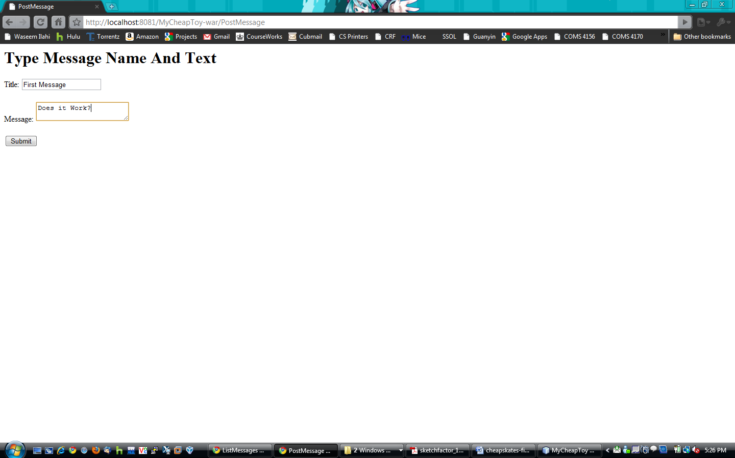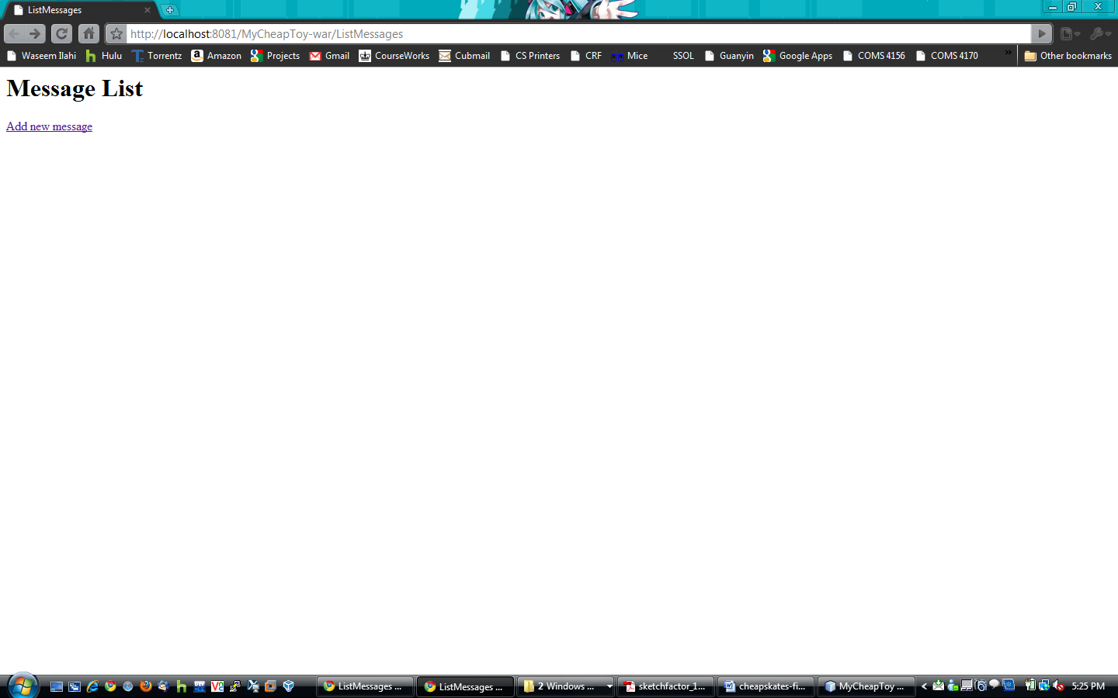

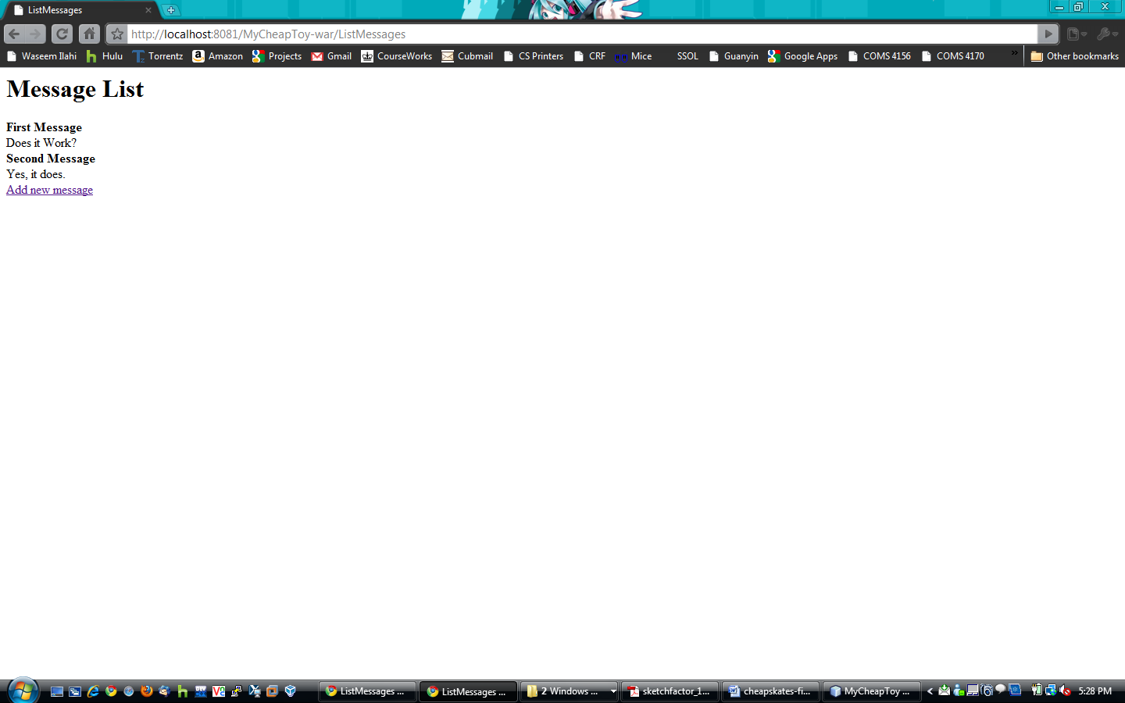

# 7. Controversies

There are no controversies among the team at this point.